Test Case: tc003_SPX_Dev5_Crear_Requisicion_Spot_Tipo_Cobro_CC_Urgent
Step 1 - Enter username and password and click to button Enter : Credentials Entered
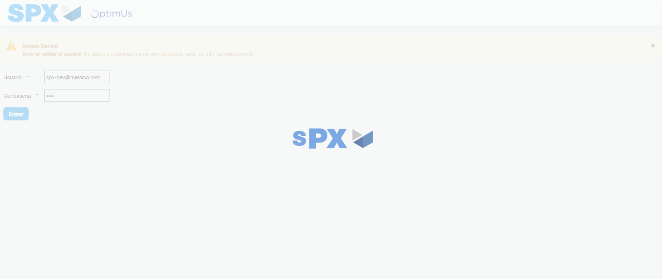Image file-name: QC_Testing-tc003_SPX_Dev5_Crear_Requisicion_Spot_Tipo_Cobro_CC_Urgent-1785344594359

Step 2 - Select to UEN and Access to Spot Buy Requisitions : UEN Correctly selected and Correct access
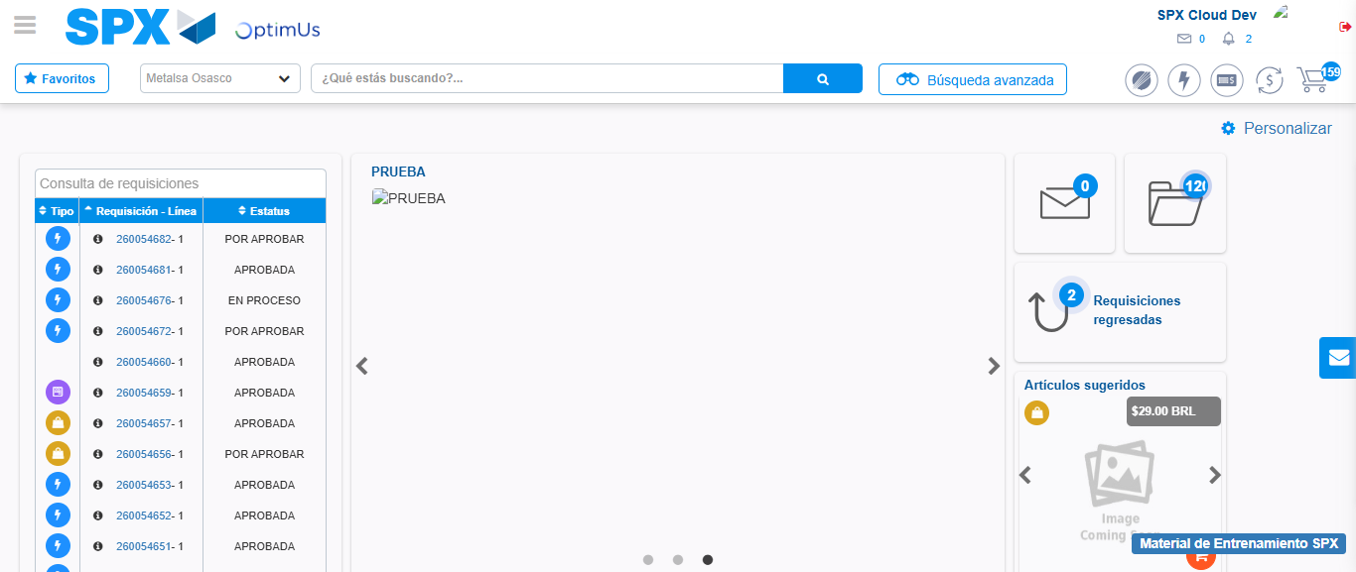Image file-name: QC_Testing-tc003_SPX_Dev5_Crear_Requisicion_Spot_Tipo_Cobro_CC_Urgent-1785344620171

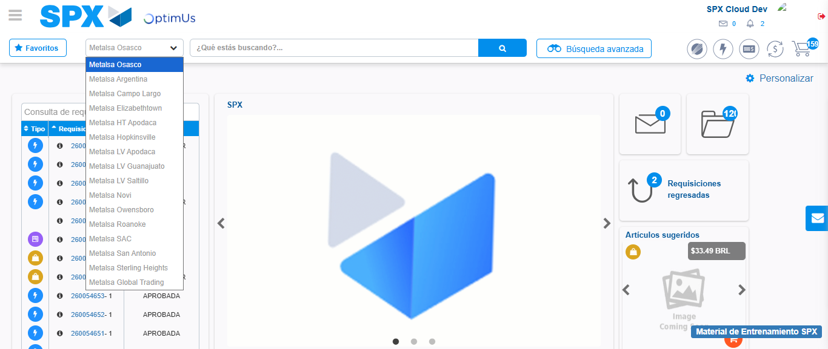Image file-name: QC_Testing-tc003_SPX_Dev5_Crear_Requisicion_Spot_Tipo_Cobro_CC_Urgent-1785344622729

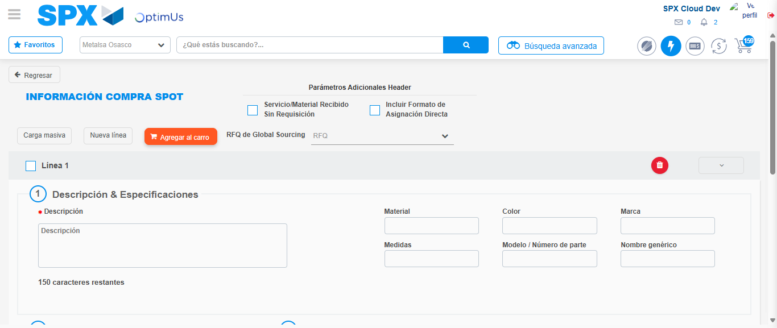Image file-name: QC_Testing-tc003_SPX_Dev5_Crear_Requisicion_Spot_Tipo_Cobro_CC_Urgent-1785344642304

Step 3 - Data Capture Spot Buy Requisition: Data captured correctly
Image file-name: QC_Testing-tc003_SPX_Dev5_Crear_Requisicion_Spot_Tipo_Cobro_CC_Urgent-1785344642518

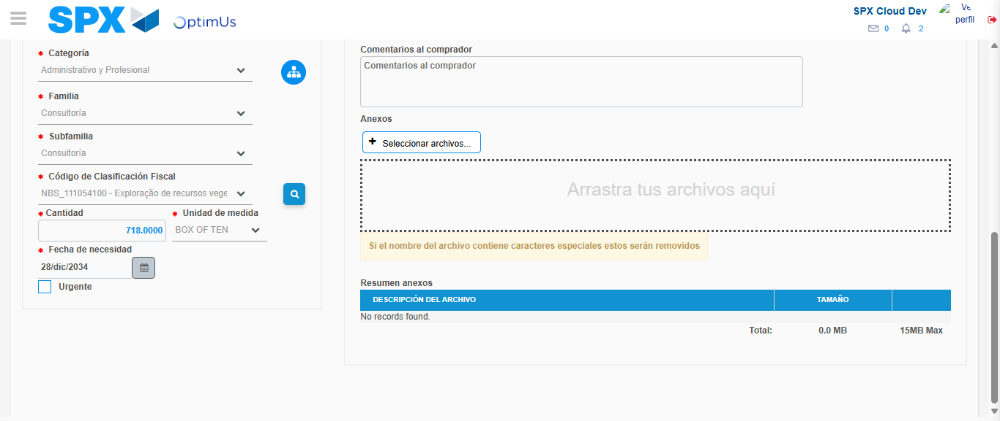Image file-name: QC_Testing-tc003_SPX_Dev5_Crear_Requisicion_Spot_Tipo_Cobro_CC_Urgent-1785344656036

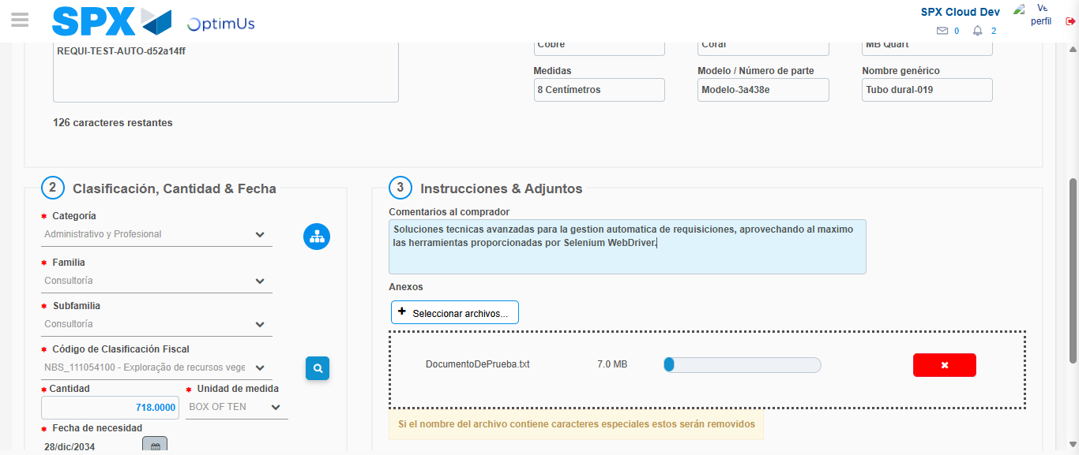Image file-name: QC_Testing-tc003_SPX_Dev5_Crear_Requisicion_Spot_Tipo_Cobro_CC_Urgent-1785344656793

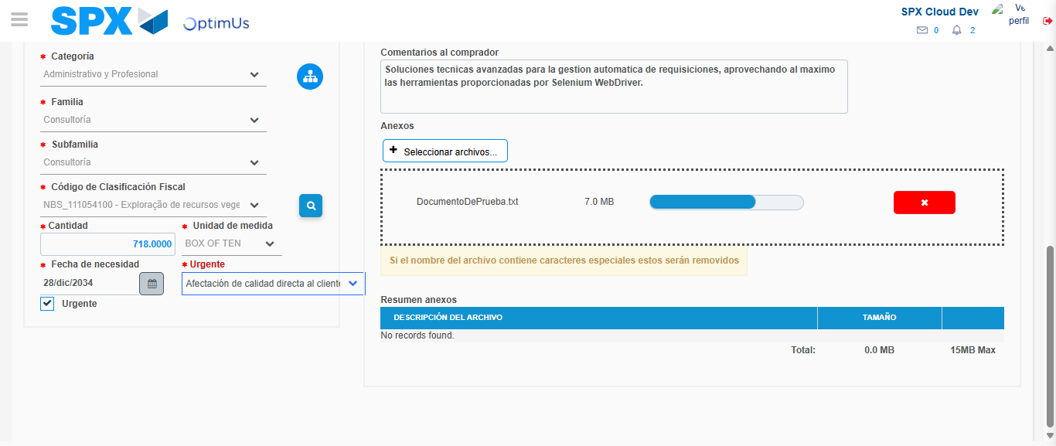Image file-name: QC_Testing-tc003_SPX_Dev5_Crear_Requisicion_Spot_Tipo_Cobro_CC_Urgent-1785344661010

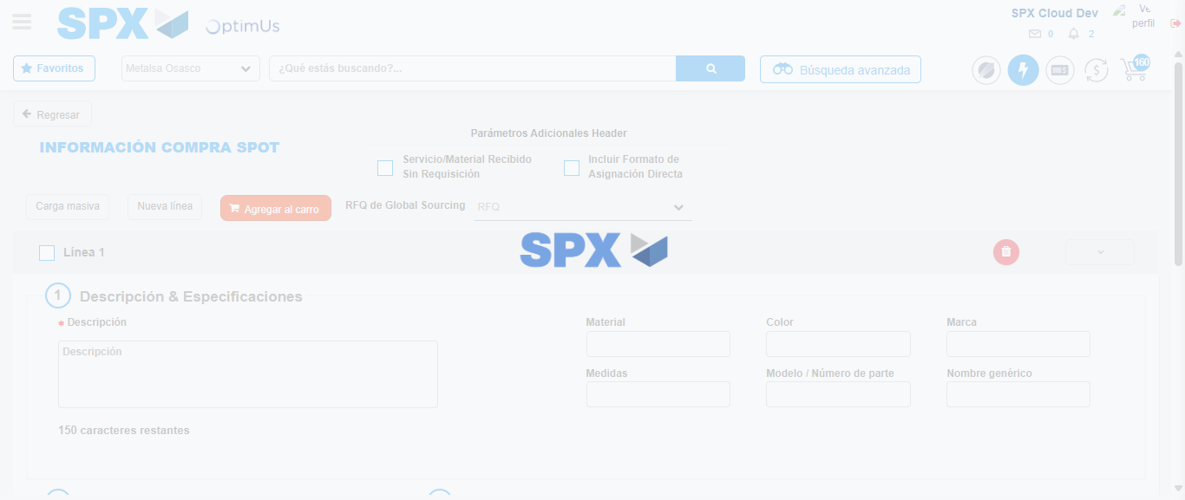Image file-name: QC_Testing-tc003_SPX_Dev5_Crear_Requisicion_Spot_Tipo_Cobro_CC_Urgent-1785344669600

Step 7 - Return to Main Page SPX : Return to Main Page SPX
Image file-name: QC_Testing-tc003_SPX_Dev5_Crear_Requisicion_Spot_Tipo_Cobro_CC_Urgent-1785344620171

Image file-name: QC_Testing-tc003_SPX_Dev5_Crear_Requisicion_Spot_Tipo_Cobro_CC_Urgent-1785344622729

Image file-name: QC_Testing-tc003_SPX_Dev5_Crear_Requisicion_Spot_Tipo_Cobro_CC_Urgent-1785344642304

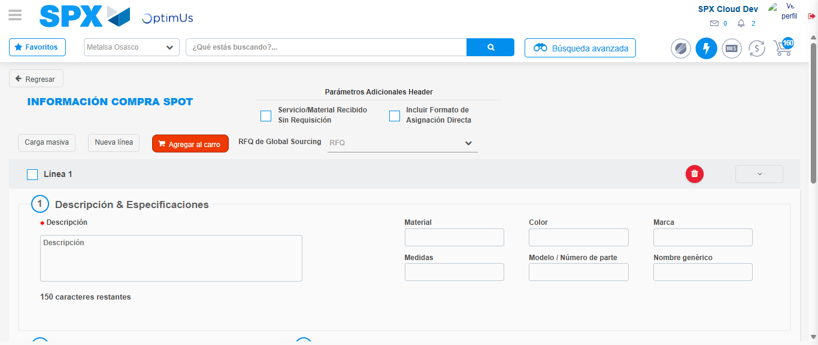Image file-name: QC_Testing-tc003_SPX_Dev5_Crear_Requisicion_Spot_Tipo_Cobro_CC_Urgent-1785344671810

Image file-name: QC_Testing-tc003_SPX_Dev5_Crear_Requisicion_Spot_Tipo_Cobro_CC_Urgent-1785344671960

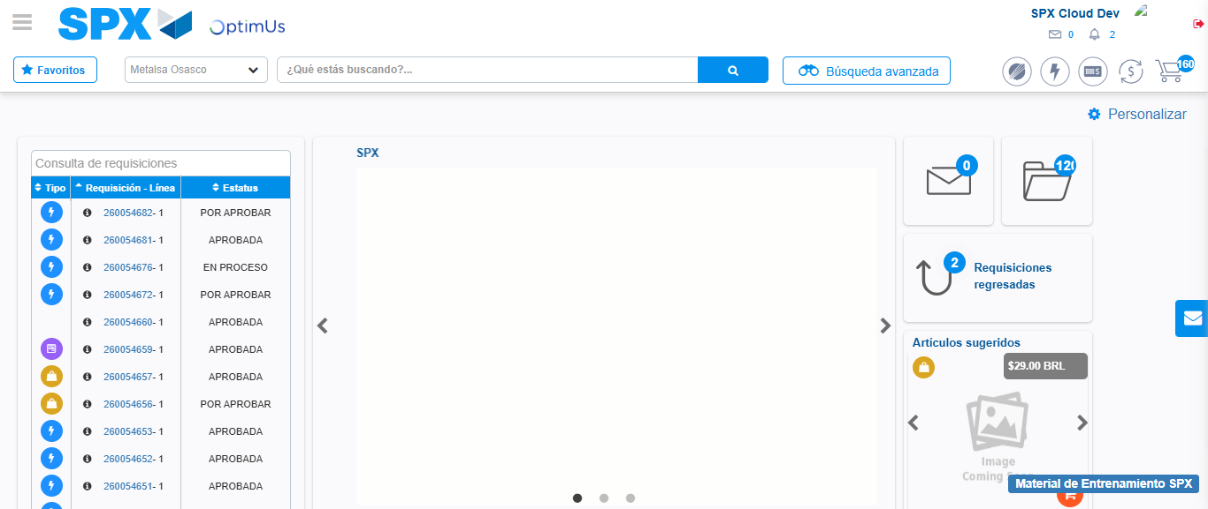Image file-name: QC_Testing-tc003_SPX_Dev5_Crear_Requisicion_Spot_Tipo_Cobro_CC_Urgent-1785344692981

Step 8 - Log Out : Log Out SPX
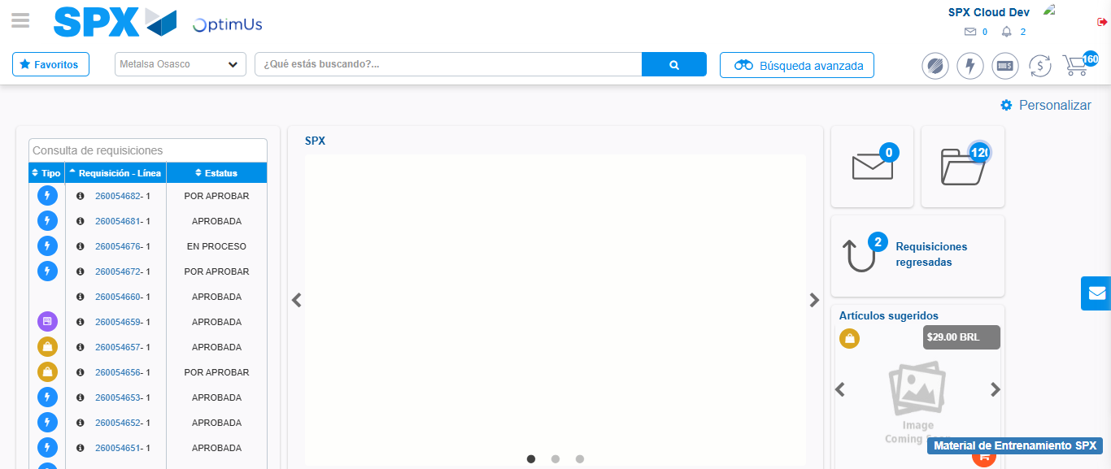Image file-name: QC_Testing-tc003_SPX_Dev5_Crear_Requisicion_Spot_Tipo_Cobro_CC_Urgent-1785344693255

